CI/CD + SonarQube + Docker + Kubernetes + Argo CD + Prometheus + Grafana monitoring
GitHub Actions + SonarQube + Docker + EKS Project
1. Create and Clone the GitHub Repository
Create an empty repository in GitHub with the name:
Github-Actions-Project
Open VS Code → Terminal → Git Bash and clone the repository:
git clone https://github.com/harathi-mutyam/Github-Actions-Project.git
2. Push Local Code to GitHub (optional here)
Open Git Bash in the project directory.
Remove the existing Git configuration:
rm -rf .git
Initialize Git:
git init
Rename the branch to main:
git branch -M main
Add the .gitignore file:
git add .gitignore
Commit the changes:
git commit -m "Add gitignore to project"
Add all project files:
git add .
Commit the project:
git commit -m "project"
Add the GitHub remote repository:
git remote add origin https://github.com/harathi-mutyam/Github-Actions-Project.git
Push the code:
git push -f origin main
3. Create the AWS Security Group
Open the AWS Console → EC2 → Security Groups.
Create a security group named:
githubaction_sg
Configure the required inbound rules:
Type | Protocol | Port | Source
SMTPS | TCP | 465 | Anywhere IPv4
Custom TCP | TCP | 587 | Anywhere IPv4
Custom TCP | TCP | 3000–11000 | Anywhere IPv4
HTTP | TCP | 80 | Anywhere IPv4
HTTPS | TCP | 443 | Anywhere IPv4
SSH | TCP | 22 | My IP
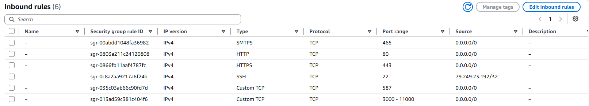
4. Create the GitHub Actions Self-Hosted Runner
Create an EC2 instance with the following configuration:
- Name: Runner
- OS: Ubuntu
- Instance type: c7i-flex.large
- Key pair: github-key
- Security Group: githubaction_sg
- Storage: 25 GB
Connect to the instance using Git Bash:
ssh -i Downloads/github-key.pem ubuntu@<public-ip-of-runner-ec2-instance>
Update the system:
sudo apt update
Set the hostname:
sudo hostnamectl set-hostname runner
/bin/bash
5. Configure the GitHub Self-Hosted Runner
Open your GitHub repository:
Actions → Runners → Self Hosted Runner New self-hosted runner → Linux
Copy the commands displayed by GitHub and execute them on the Runner EC2 instance.
For reference:
copy those commandsopen Runner gitbashpaste those commands and run itAgain go back to git hub repository in browser copy the download the latest runner package commandpaste it in Runner gitbash and run it again open in browser github respository copy the extract the installer commandpaste it in the Runner gitbash and run it
After downloading and extracting the runner package:
cd actions-runner
Check the files:
ls
If required, remove the downloaded tar file:
rm actions-runner-linux-x64-2.322.0.tar.gz
ls
For Reference:
Now Configure the Runner: open github repository in browser copy the command related to create Runner & start the Configuration experience paste it in EC2 Runner Gitbash & run it
Press Enter for Default here type: Press EnterEnterType Runner1 Provide Labels: here type self-hosted
Enter the name of work folder: Press enter key here for default

Configure the runner using the command provided by GitHub.
When prompted:
- Press Enter for the default values where appropriate.
- Enter Runner1 as the runner name.
- Enter self-hosted as the label.
- Press Enter to use the default work folder.
ls
for reference: Open github repository in browseropen same repository in duplicate browserselect settings -->actionsrunnersNow you can see Runner1 is in offline
open EC2 runner gitbash run the below command
Start the runner:
./run.sh
You should see a message similar to:
Connected to GitHub
Listening for Jobs
The runner is now connected to GitHub and ready to execute GitHub Actions jobs.
For referece: Open guthub repository in browser Refresh the pageYou can observe status changed to idle or active
6. Install Maven on the Runner
Check the cicd.yaml file in:
.github/workflows/cicd.yaml
Since the workflow uses Maven, Maven must be installed on the Runner EC2 instance.
Open one more gitbash for installation purpose
Connect to the Runner:
ssh -i Downloads/github-key.pem ubuntu@<public-ip-of-runner-ec2-instance>
sudo hostnamectl set-hostname runnerinstalationpurpose

/bin/bash
Install Maven:
sudo apt install maven -y
Go to GitHub → Actions and run the workflow again.(click on re-run jobs)
At this stage, the pipeline should proceed successfully through the compe job phase.
7. Create the SonarQube EC2 Instance
Create another EC2 instance for SonarQube.
Configuration:
- Name: SonarQube
- OS: Ubuntu
- Instance type: c7i-flex.large
- Key pair: github-key (old one)
- Security Group: githubaction_sg (old one)
- Storage: 25 GB
Connect to the SonarQube instance:
ssh -i Downloads/github-key.pem ubuntu@<public-ip-of-sonarqube-ec2-instance>
Set the hostname:
sudo hostnamectl set-hostname sonarqube
/bin/bash
Update the system:
sudo apt update

Install Docker: type
docker #Install docker through sonarqube
sudo apt install docker.io -y
Add the current user to the Docker group:
sudo usermod -aG docker $USER
Apply the group changes:
newgrp docker
Run SonarQube:
docker run -d --name sonar -p 9000:9000 sonarqube:lts-community
8. Open SonarQube
Open a browser and enter:
http://<sonarqube-ec2-public-ip>:9000
Use the default login credentials:
Username: admin
Password: admin
After login, the Change Password page will appear.
Enter:
Old Password: admin
New Password: admin123
Confirm Password: admin123
Click Update Password.
You will then be redirected to the SonarQube dashboard.
9. Generate the SonarQube Token
In SonarQube:
Administration(top navigation bar) → Security → Users
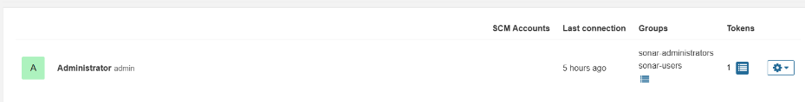
Under the token section click on this symbol .It will open this page
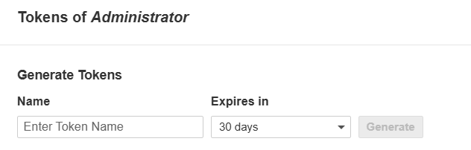
Using the above one generate a new token.
Provide a name for the token (Name : A) and click Generate.
Copy the generated token and store it securely.
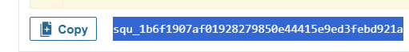
10. Add SonarQube Secrets to GitHub
Open:
Our project GitHub Repository in browser → Settings → under Security and quality Secrets and variables → Actions-select secrets tabnew repository secret button
Create a repository secret:
Name: SONAR_TOKEN (The name must be match the name used in cicd.yaml file under build_project_and_sonar_scan: job)
Value: paste the <SonarQube-token> here
The name must match the name used in cicd.yaml.
Create a repository variable:
Now select variable tab new Repository Variable

Name: SONAR_HOST_URL
Value: http://<sonarqube-ec2-public-ip>:9000
The variable name must also match the name used in cicd.yaml
11. Install Docker on the GitHub Actions Runner
If the pipeline fails during the Docker stage, install Docker on the Runner EC2 instance( for that open runnerinstalationpurpose gitbash).

Follow the official Docker installation instructions for Ubuntu.
For reference: open google in browser search docker install in ubuntuclick the official link https://docs.docker.com/engine/install/ubuntu/
copy the Set up Docker's apt repository commands from browser , paste and run in

runnerinstalationpurpose gitbash terminal

# Add Docker's official GPG key:
sudo apt update
sudo apt install ca-certificates curl
sudo install -m 0755 -d /etc/apt/keyrings
sudo curl -fsSL https://download.docker.com/linux/ubuntu/gpg -o /etc/apt/keyrings/docker.asc
sudo chmod a+r /etc/apt/keyrings/docker.asc

# Add the repository to Apt sources:
sudo tee /etc/apt/sources.list.d/docker.sources <<EOF
Types: deb
URIs: https://download.docker.com/linux/ubuntu
Suites: $(. /etc/os-release && echo "${UBUNTU_CODENAME:-$VERSION_CODENAME}")
Components: stable
Architectures: $(dpkg --print-architecture)
Signed-By: /etc/apt/keyrings/docker.asc
EOF

sudo apt update

copy Install the Docker packages commands from the official docker website run those commands in runnerinstalationpurpose gitbash terminal
sudo apt install docker-ce docker-ce-cli containerd.io docker-buildx-plugin docker-compose-plugin

After installing Docker, add the Ubuntu user to the Docker group:
sudo usermod -aG docker ubuntu
Apply the changes:
newgrp docker
for reference: close the both runner related gitbashes: runnerinstalationpurpose gitbash and runner gitbash also.
Reconnect to the Runner and start the GitHub Actions runner again:
ssh -i Downloads/github-key.pem ubuntu@<public-ip of runner ec2-instance>
sudo hostnamectl set-hostname runner

/bin/bash
ls
cd actions-runner
./run.sh
Your original notes use the official Docker Ubuntu website for installation process.
12. Configure Docker Hub
Open the cicd.yaml file and update the Docker image name with your Docker Hub username and application name.
Example:
tags: harathi2026/bankapp:latest
Create a Dcoker username and password in our github repository as secrets and variable:
Open again our project github repository page in browsersettingsunder Security and qualityselect Secrets and variablesselect Actionsselect secrets Tabnew repository secret button
Name: DOCKERHUB_TOKEN (name must be match in cicd.yaml file under build_docker_image_and_push: job)
Secret: Enter Your Docker password Click on Add secret button

select variables Tabnew repository variable button
Name: DOCKERHUB_USERNAME (name must be match in cicd.yaml file under build_docker_image_and_push: job)
Value: Enter Your Docker username Click on Add Variable button

Create the following GitHub repository secret:
DOCKERHUB_TOKEN
Store your Docker Hub password/token as the secret value.
Create the following repository variable:
DOCKERHUB_USERNAME
Store your Docker Hub username as the value.
Commit the changes and run the GitHub Actions workflow again.
For reference:

Open cicd.yaml file commit the changes or click on Actions rerun the job

13. Create the EC2 Server for EKS
Create another EC2 instance to create the EKS cluster.
Configuration:
- Name: Server
- OS: Ubuntu
- Instance type: c7i-flex.large
- Key pair: github-key
- Security Group: githubaction_sg
- Storage: 25 GB
Connect to the server: open one more gitbash terminal
ssh -i Downloads/github-key.pem ubuntu@<public-ip-of-server-ec2-instance>

Update the system:
sudo apt update
Set the hostname:
sudo hostnamectl set-hostname server
/bin/bash

14. Install unzip , AWS CLI
Install the required packages:
sudo apt update
sudo apt install unzip -y
Download AWS CLI:
curl "https://awscli.amazonaws.com/awscli-exe-linux-x86_64.zip" -o "awscliv2.zip"
Extract it:
unzip awscliv2.zip
Install AWS CLI:
sudo ./aws/install
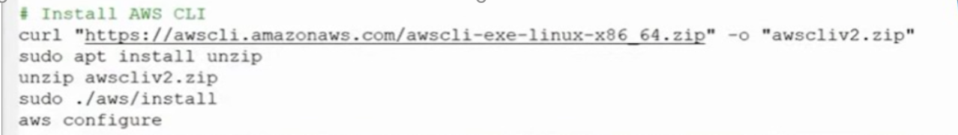
For reference:
open aws console in browsergenerate Access key and secret key for IAM user or for Root user

click on Root user (rightside top corner)security credentialsselect create a access keyselect the check box I understandselect create access key button copy or download the secret and access keys

Configure AWS:
aws configure
Provide:
AWS Access Key ID: paste <your-access-key> here
AWS Secret Access Key: paste <your-secret-key> here
Default region name: eu-north-1
Default output format: json
15. Install Terraform
Install the required packages:
sudo apt-get update && sudo apt-get install -y gnupg software-properties-common curl
Add the HashiCorp GPG key:
wget -O- https://apt.releases.hashicorp.com/gpg | \
gpg --dearmor | \
sudo tee /usr/share/keyrings/hashicorp-archive-keyring.gpg > /dev/null
Add the HashiCorp repository:
echo "deb [signed-by=/usr/share/keyrings/hashicorp-archive-keyring.gpg] \
https://apt.releases.hashicorp.com $(lsb_release -cs) main" | \
sudo tee /etc/apt/sources.list.d/hashicorp.list
Install Terraform:
sudo apt-get update && sudo apt-get install terraform
Verify the installation:
terraform --version
These are the Terraform installation steps documented in my project notes.
# 1. Install prerequisites
sudo apt-get update && sudo apt-get install -y gnupg software-properties-common curl
# 2. Add HashiCorp GPG key
wget -O- https://apt.releases.hashicorp.com/gpg | gpg --dearmor | sudo tee /usr/share/keyrings/hashicorp-archive-keyring.gpg > /dev/null
# 3. Add the repository
echo "deb [signed-by=/usr/share/keyrings/hashicorp-archive-keyring.gpg] \
https://apt.releases.hashicorp.com $(lsb_release -cs) main" | sudo tee /etc/apt/sources.list.d/hashicorp.list
# 4. Update and install
sudo apt-get update && sudo apt-get install terraform
# 5. Verify installation
terraform –version

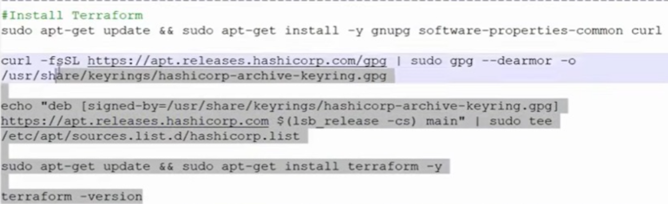

16. Clone the EKS Terraform Code
The EKS Terraform code is also stored in the GitHub Actions project repository.
Before cloning the project, open variables.tf and update the SSH key name:
variable "ssh_key_name" {
description = "The name of the SSH key pair to use for instances"
type = string
default = "github-key"
}
Replace github-key with the key pair name you are using in ec2 instances(runner,sonarqube,server instances).
Also check main.tf and update the AWS region if required:
provider "aws" {
region = "eu-north-1"
}
Clone the repository in server instance gitbash terminal:
git clone https://github.com/harathi-mutyam/Github-Actions-Project.git
Move into the project directory:
cd Github-Actions-Project
Initialize Terraform:
terraform init
Create the infrastructure:
terraform apply --auto-approve
EKS deployment producing cluster, node group, subnet, and VPC outputs.
17 resources must be created
Copy the
cluster_id = "eks-cluster"
node_group_id = "eks-cluster:eks-node-group"
subnet_ids = [
"subnet-0f697578532397c9a",
"subnet-00efb5a12c4ec3159",
]
vpc_id = "vpc-0c7afca4f7cfd81cd"
17. Install kubectl in server Gitbash terminal
Download kubectl:
curl -LO "https://dl.k8s.io/release/$(curl -L -s https://dl.k8s.io/release/stable.txt)/bin/linux/amd64/kubectl"
curl -LO "https://dl.k8s.io/release/$(curl -L -s https://dl.k8s.io/release/stable.txt)/bin/linux/amd64/kubectl.sha256"
Install it:
sudo install -o root -g root -m 0755 kubectl /usr/local/bin/kubectl
Verify:
kubectl version –client
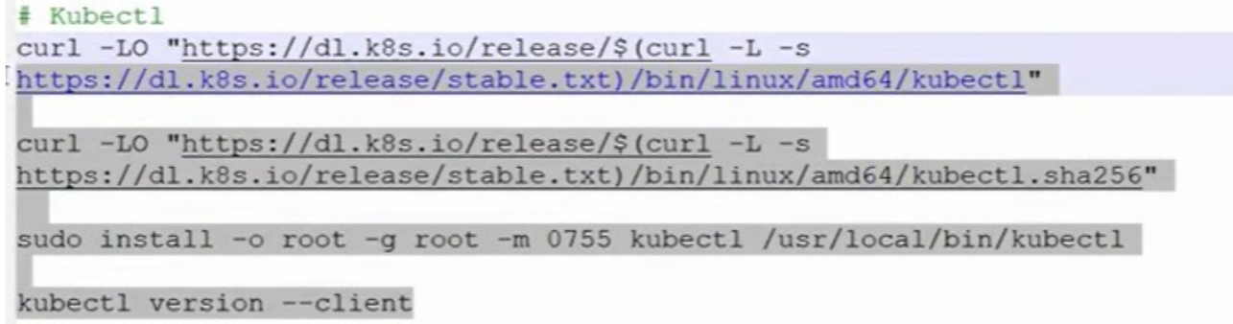
18. Configure kubectl for EKS
Update the kubeconfig:
aws eks update-kubeconfig --region eu-north-1 --name <your-eks-cluster-name>
aws eks update-kubeconfig --region eu-north-1 --name eks-cluster
Verify the worker nodes:
kubectl get nodes
ls
View the kubeconfig:
cat ~/.kube/config
The kubeconfig content is then used for the GitHub Actions deployment configuration.

19. Add EKS Secrets to GitHub
Go to:
GitHub Repository → Settings → Secrets and variables → Actions → Secrets
Create:
Name: EKS-KUBECONFIG
Value: <entire ~/.kube/config content>
Also create:
AWS_ACCESS_KEY_ID
AWS_SECRET_ACCESS_KEY
Store the corresponding AWS credentials as GitHub Actions secrets.
For reference: Save the aws access key and secret key as secrets in our project github repository
Select secrets tabselect new repository secret button
name: AWS_ACCESS_KEY_ID
secret : paste the aws access key value from aws account here save it
Select secrets tabselect new repository secret button
name: AWS_SECRET_ACCESS_KEY
secret : paste the aws secret key value from aws account here save it
Then go to Actions and run the pipeline again.
20. Install AWS CLI and kubectl on the Runner
If the GitHub Actions runner reports that AWS CLI is missing, install it on the Runner EC2 instanceopen runnerinstalationpurpose gitbash terminal.
cd actions-runner
Check AWS CLI:
aws --version
Install AWS CLI if required:
sudo apt update
sudo apt install -y unzip curl
curl "https://awscli.amazonaws.com/awscli-exe-linux-x86_64.zip" -o "awscliv2.zip"
unzip awscliv2.zip
sudo ./aws/install
Verify:
aws --version
Install kubectl:
curl -LO "https://dl.k8s.io/release/$(curl -L -s https://dl.k8s.io/release/stable.txt)/bin/linux/amd64/kubectl"
sudo install -o root -g root -m 0755 kubectl /usr/local/bin/kubectl
Verify:
kubectl version --client
Run the GitHub Actions pipeline again from the github repository.
21. Verify the Application
After the GitHub Actions pipeline completes successfully, open the Server Git Bash terminal.
Run:
kubectl get all
Find the application's DNS name from the output.
Open the DNS name in a browser and verify that the application is accessible.
Then:
- Register a new user.
- Create a username and password.
- Log in using the new credentials.
- Verify that the application is working correctly.


STEP 4 — Create a k8s folder in eks cluster
Open server girbash terminal
Run:
mkdir -p k8s
Check:
ls
You should now see:
k8s

STEP 5 — Create namespace.yaml
Run:
vim k8s/namespace.yaml
press i , :set mouse= , right click paste the content
Paste:
apiVersion: v1
kind: Namespace
metadata:
name: bankapp
Save:
:wq!
STEP 6 — Create deployment.yaml
Run:
vim k8s/deployment.yaml
Paste:
---
# MySQL Deployment
apiVersion: apps/v1
kind: Deployment
metadata:
name: mysql
namespace: bankapp
spec:
selector:
matchLabels:
app: mysql

strategy:
type: Recreate

template:
metadata:
labels:
app: mysql

spec:
containers:
- image: mysql:8
name: mysql

env:
- name: MYSQL_ROOT_PASSWORD
value: "Test@123"

- name: MYSQL_DATABASE
value: "bankappdb"

ports:
- containerPort: 3306
name: mysql

---
# Bankapp Deployment
apiVersion: apps/v1
kind: Deployment
metadata:
name: bankapp
namespace: bankapp
spec:
replicas: 1

selector:
matchLabels:
app: bankapp

template:
metadata:
labels:
app: bankapp

spec:
containers:
- name: bankapp
image: harathi2026/bankapp:latest

ports:
- containerPort: 8080

env:
- name: SPRING_DATASOURCE_URL
value: jdbc:mysql://mysql-service:3306/bankappdb?useSSL=false&serverTimezone=UTC&allowPublicKeyRetrieval=true

- name: SPRING_DATASOURCE_USERNAME
value: root

- name: SPRING_DATASOURCE_PASSWORD
value: "Test@123"
Save and exit.

STEP 7 — Create service.yaml
Run:
vim k8s/service.yaml
Paste:
---
# MySQL Service
apiVersion: v1
kind: Service
metadata:
name: mysql-service
namespace: bankapp
spec:
ports:
- port: 3306
selector:
app: mysql

---
# Bankapp Service
apiVersion: v1
kind: Service
metadata:
name: bankapp-service
namespace: bankapp
spec:
type: LoadBalancer

ports:
- port: 80
targetPort: 8080

selector:
app: bankapp
Save and exit.

STEP 8 — Check your new files
Run:
ls k8s
You should see:
deployment.yaml
namespace.yaml
service.yaml
So your project now looks like:
Github-Actions-Project
│
├── k8s
│ ├── namespace.yaml
│ ├── deployment.yaml
│ └── service.yaml
│
├── ds.yml
├── Dockerfile
├── pom.xml
└── ...
Do not delete ds.yml yet.
We will delete it only after we confirm the new files work.

STEP 9 — Test Kubernetes
Now we actually deploy the new files.
First:
kubectl apply -f k8s/namespace.yaml
You should get:
namespace/bankapp created
Then:
kubectl apply -f k8s/deployment.yaml
Then:
kubectl apply -f k8s/service.yaml

STEP 10 — Check the application
Run:
kubectl get all -n bankapp
You should see something similar to:
NAME READY
pod/mysql-xxxxxxxx 1/1
pod/bankapp-xxxxxxxx 1/1

NAME TYPE
service/mysql-service ClusterIP
service/bankapp-service LoadBalancer

NAME READY
deployment.apps/mysql 1/1
deployment.apps/bankapp 1/1
Don't worry if it takes some time.
Check:
kubectl get pods -n bankapp
You want:
mysql-xxxxx 1/1 Running
bankapp-xxxxx 1/1 Running

STEP 11 — Test your Bankapp
Run:
kubectl get svc -n bankapp
Look for:
bankapp-service
You should eventually see an AWS LoadBalancer hostname in:
EXTERNAL-IP
For example:
a123456789.eu-north-1.elb.amazonaws.com
Open that address in your browser.
Because your service is:
port: 80
targetPort: 8080
you should normally access it using:
http://LOAD-BALANCER-DNS

ubuntu@server:~/banking-app-cicd$

- Check hidden files
ls -la
ls -la .github
ls -la .github/workflows
you can see the cicd.yml
vim .github/workflows/cicd.yml

Then make your required change
Inside Vim:
vim .github/workflows/cicd.yml
Find:
- name: Deploy to EKS
run: |
kubectl apply -f ds.yml
Change to:
- name: Deploy to EKS
run: |
kubectl apply -f k8s/
Save:
Esc
:wq
Enter

hen check the change
git diff
You should see that cicd.yml was changed.
Then:
git add .github/workflows/cicd.yml

git commit -m "Update Kubernetes deployment path"
git push origin main
2. Git needs your name and email
Your commit failed because Git doesn't know the identity to attach to the commit.
You can configure it on this Ubuntu server.
Use your GitHub email:
git config --global user.name "Harathi Mutyam"
git config --global user.email "ehmutyam@gmail.com"
Check:
git config --global --list
You should see:
user.name=Harathi Mutyam
user.email=ehmutyam@gmail.com
3. Commit again
Your files are already staged, so simply run:
git commit -m "Organize Kubernetes manifests"

You should get something similar to:
[main xxxxxxx] Organize Kubernetes manifests
... files changed ...
to set your account's default identity. Omit --global to set the identity only in this repository. fatal: unable to auto-detect email address (got 'ubuntu@server.(none)')
GitHub authentication problem

Set up SSH authentication
Since this is your Ubuntu server/EC2 and you'll push from it repeatedly, SSH is a good option.
Step 1 — Check if you already have an SSH key
Run:
ls -la ~/.ssh
If you see something like:
id_ed25519
id_ed25519.pub
you may already have a key.
If you don't have an SSH key, create one:
ssh-keygen -t ed25519 -C "ehmutyam@gmail.com"
When you see:
Enter file in which to save the key (/home/ubuntu/.ssh/id_ed25519):
just press Enter.
For the passphrase, you can press Enter twice if you want no passphrase for this learning server.

Step 2 — Display your public key
Run:
cat ~/.ssh/id_ed25519.pub
You'll get something beginning with:
ssh-ed25519 AAAA...
example: ssh-ed25519 AAAAC3NzaC1lZDI1NTE5AAAAIEqRKYmX3rilFQRroG+4x1/KHE06U0EcRvVdEbb/NWnG ehmutyam@gmail.com

Copy the entire single line.
⚠️ Copy only the .pub key. Never share:
~/.ssh/id_ed25519
The private key must remain secret.

Step 3 — Add the key to GitHub
In GitHub:
Profile picture → Settings → SSH and GPG keys → New SSH key
Enter:
Title:
Ubuntu EC2 Server
Key type:
Authentication Key
Key:
Paste the output from:
cat ~/.ssh/id_ed25519.pub
Save it.

Step 4 — Test GitHub SSH
On your Ubuntu server:
ssh -T git@github.com
The first time, you may see:
Are you sure you want to continue connecting (yes/no/[fingerprint])?
Type:
yes
A successful result will say something similar to:
Hi harathi-mutyam! You've successfully authenticated...

Step 5 — Change your Git remote from HTTPS to SSH
Currently yours is:
https://github.com/harathi-mutyam/banking-app-cicd.git
Change it:
git remote set-url origin git@github.com:harathi-mutyam/banking-app-cicd.git
Check:
git remote -v
You should now see:
origin git@github.com:harathi-mutyam/banking-app-cicd.git (fetch)
origin git@github.com:harathi-mutyam/banking-app-cicd.git (push)

Step 6 — Push your already-created commit
git push origin main

git status

git pull --rebase origin main

git push origin main

previous history for reference
30 mkdir -p k8s
31 ls
32 vim k8s/namespace.yaml
33 vim k8s/deployment.yaml
34 vim k8s/service.yaml
35 ls k8s
36 kubectl apply -f k8s/namespace.yaml
37 kubectl apply -f k8s/deployment.yaml
38 kubectl apply -f k8s/service.yaml
39 kubectl get all -n bankapp
40 ls
41 vim .github/workflows/cicd.yaml

64 git status
65 git add k8s/
66 git add .github/workflows/cicd.yaml
67 git add .github/workflows/cicd.yml
68 git commit -m "Organize Kubernetes manifests"
69 git config --global user.name "Harathi Mutyam"
70 git config --global user.email "ehmutyam@gmail.com"
71 git config --global --list
72 git commit -m "Organize Kubernetes manifests"
73 git config --global user.name "Harathi Mutyam"
74 git config --global user.email "ehmutyam@gmail.com"
75 git commit -m "Organize Kubernetes manifests"
76 git push origin main
77 ls -la ~/.ssh
78 ssh-keygen -t ed25519 -C "ehmutyam@gmail.com"
79 ls -la ~/.ssh
80 cat ~/.ssh/id_ed25519.pub
81 ssh -T git@github.com
82 git remote set-url origin git@github.com:harathi-mutyam/banking-app-cicd.git
83 git remote -v
84 efdfe89 Organize Kubernetes manifests
85 git push origin main
86 git status
87 git pull --rebase origin main
88 git push origin main

git add k8s/

git add .github/workflows/cicd.yml

git commit -m "Organize Kubernetes manifests"

git push origin main

Then go to:
Do not change the rest of your GitHub Actions workflow yet.
Your workflow will still do:
Build
↓
Test
↓
SonarQube
↓
Docker
↓
Push
↓
Deploy to EKS

STEP 13 — Push these changes to GitHub
After everything works:
git status
Then:
git add k8s/
Then:
git add .github/workflows/cicd.yml
Commit:
git commit -m "Organize Kubernetes manifests"
Push:
git push origin main
Then go to:
GitHub → Github-Actions-Project → Actions
Check that your workflow succeeds.

Cd part

Run these commands in order: you can see the explanation below
kubectl get nodes
kubectl create namespace argocd
kubectl apply -n argocd \
--server-side \
--force-conflicts \
-f https://raw.githubusercontent.com/argoproj/argo-cd/stable/manifests/install.yaml
Then:
kubectl get pods -n argocd

STEP 14 — Start Argo CD
Where should you run these commands?
Run them on your Server / EKS management EC2, the same server where kubectl is working.
First check that you are connected to your EKS cluster:
kubectl get nodes
You should see your EKS worker nodes, for example:
If you see Ready, continue.

STEP 14.1 — Create the Argo CD namespace
Run:
kubectl create namespace argocd
Expected output:
namespace/argocd created
Check it
kubectl get namespace argocd
Expected:
NAME STATUS AGE
argocd Active ...

STEP 14.2 — Install Argo CD
Now run this command:
kubectl apply -n argocd \
--server-side \
--force-conflicts \
-f https://raw.githubusercontent.com/argoproj/argo-cd/stable/manifests/install.yaml
This command tells Kubernetes:
"Install the Argo CD components inside my EKS cluster in the argocd namespace."
You should see several resources being created, such as:
customresourcedefinition.apiextensions.k8s.io/applications.argoproj.io created
customresourcedefinition.apiextensions.k8s.io/applicationsets.argoproj.io created
service/argocd-server created
deployment.apps/argocd-server created
...

STEP 14.3 — Check Argo CD Pods
Wait about 1–2 minutes, then run:
kubectl get pods -n argocd
You should eventually see pods similar to:
NAME READY STATUS
argocd-application-controller-xxxx 1/1 Running
argocd-applicationset-controller-xxxx 1/1 Running
argocd-dex-server-xxxx 1/1 Running
argocd-notifications-controller-xxxx 1/1 Running
argocd-redis-xxxx 1/1 Running
argocd-repo-server-xxxx 1/1 Running
argocd-server-xxxx 1/1 Running
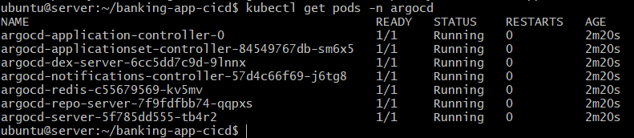
The important thing is:
STATUS = Running
and
READY = 1/1
If some pods say ContainerCreating
Wait another minute and check again:
kubectl get pods -n argocd

🛑 STOP HERE
Don't configure the GitHub repository yet.
Don't create the Argo CD Application yet.
Don't install Prometheus or Grafana yet.

Step 14.4 Change Argo CD Service to LoadBalancer using YAML
- Open the Argo CD service
kubectl edit svc argocd-server -n argocd
- Change type: CluterIP to LoadBalancer

- Save the changes (Esc → :wq → Enter.)
STEP 14.5 — Check the Service
kubectl get svc -n argocd

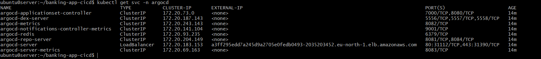
Eventually:
NAME TYPE CLUSTER-IP EXTERNAL-IP
argocd-server LoadBalancer 10.x.x.x xxx.elb.eu-north-1.amazonaws.com

Get Argo CD External Address
kubectl get svc argocd-server -n argocd
kubectl get svc argocd-server -n argocd -o wide
Copy the external ip: a3ff295edd7a245d9a2705e0fedb0493-2035203452.eu-north-1.elb.amazonaws.com
Like this
Get the Argo CD Admin Password
kubectl -n argocd get secret argocd-initial-admin-secret \ -o jsonpath="{.data.password}" | base64 -d
copy the password: qSMeoxv-YrbaeP1a
Copy this password somewhere temporarily.
Your Argo CD login details are:
Username: admin
Password: <password you just copied>

Open Argo CD in Your Browser
Then open the external address in your browser and log in.: a3ff295edd7a245d9a2705e0fedb0493-2035203452.eu-north-1.elb.amazonaws.com

Open this in your Windows browser:
https://xxx.elb.eu-north-1.amazonaws.com
You may see a browser warning about the certificate because this is the default Argo CD TLS certificate.
That's expected for this learning setup.
Proceed to the Argo CD login page.
Enter:
Username: admin
Password: <your generated password> paste it here
Press login button login
Click on user Info (on left navigation bar) update password enter old password , new password and confirm passwordsave new password

Create Argo CD Application
On the left side, click: Applications Then click: NEW APP
Fill Application Details
Application Name: bankapp
Project Name: select default
Sync Policy: Manual
Find the SOURCE section.
Repository URL: <select Your git hub respository>
https://github.com/harathi-mutyam/banking-app-cicd.git
Revision : type main
Path : k8s
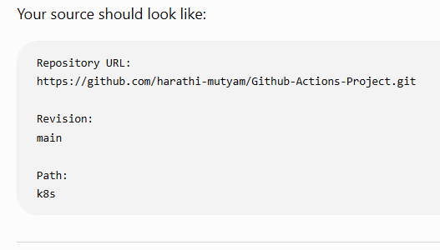
Destination:
Cluster: https://kubernetes.default.svc
Namespace: bankapp

Click on create button
Argo CD will create an application called:
bankapp

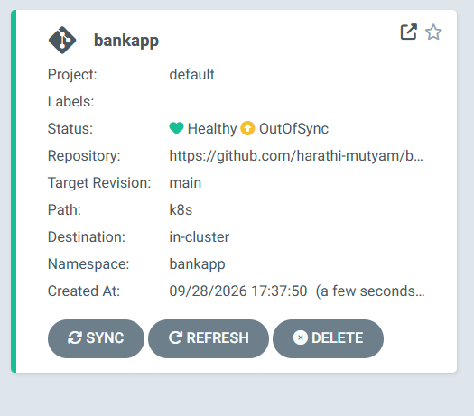
For sync your application Click on bankapp 

You should see your Kubernetes resources: Namespace , Deployment , Service
Click: SYNC Then click: SYNCHRONIZE
Argo CD will take the YAML files from:
GitHub -- ↓ k8s/ ↓ Argo CD ↓ EKS
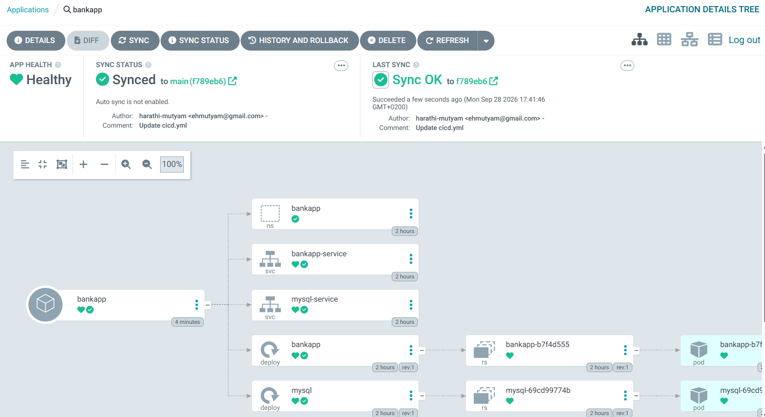

Verify from Server EC2
After synchronization finishes, go back to your Server EC2.
Run:
kubectl get all -n bankapp
You should see:
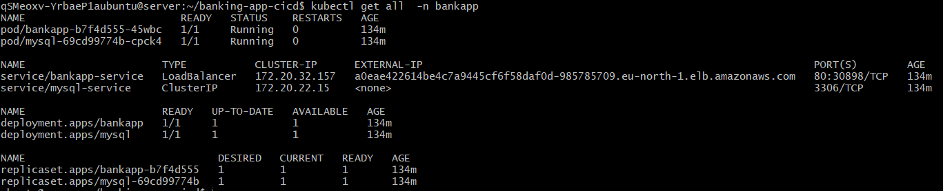
pod/mysql-xxxxx 1/1 Running pod/bankapp-xxxxx 1/1 Running
service/mysql-service service/bankapp-service
deployment.apps/mysql deployment.apps/bankapp
Also run:
kubectl get applications -n argocd
NAME SYNC STATUS HEALTH STATUS
bankapp Synced Healthy

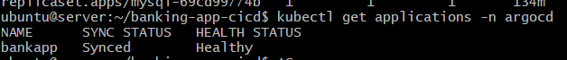
Simple steps to follow without explanation:
- Applications
- + NEW APP
- Application name → bankapp
- Project → default
- Repository → your GitHub repository
- Revision → main
- Path → k8s
- Cluster → https://kubernetes.default.svc
- Namespace → bankapp
- CREATE
- Open bankapp
- SYNC → SYNCHRONIZE
Then send me what you see in the Argo CD bankapp application — especially SYNC STATUS and HEALTH STATUS.
Now do it this one : GitHub Actions will stop deploying to EKS, and Argo CD will become responsible for CD.
Yes. Since you have created and synced the bankapp Argo CD Application, the next important step is to make the architecture a proper GitOps setup.
Remove Kubernetes Deployment from GitHub Actions
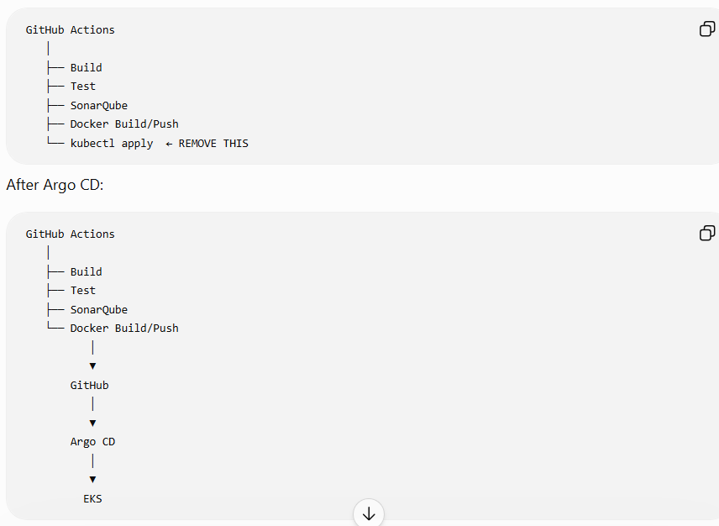

Open cicd.yml

On your Server EC2 git bash terminal you must be in banking-app-cicd
directory
cd ~/banking-app-cicd
optional command:

git status
Make sure there is no rebase or merge in progress.
If you see:
interactive rebase in progress

Get the Latest Changes from GitHub
Run:
git pull --rebase origin main
If the command completes successfully, continue to the next step.
Note: Do not run git pull --rebase again after starting a rebase. If Git reports a conflict, resolve the conflict first and run git rebase --continue.

vim .github/workflows/cicd.yml
Find the Kubernetes deployment section Remove these three steps:
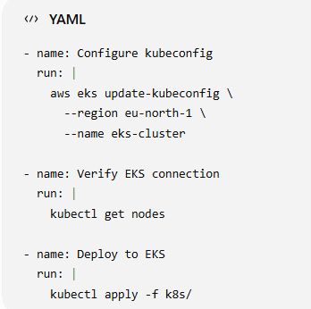
Save the file :wq!

Check the Changes
git diff
Check that only the direct Kubernetes deployment section was removed.
You should no longer have:
Configure kubeconfig
Verify EKS connection
Deploy to EKS
kubectl apply -f k8s/

git add .github/workflows/cicd.yml
git status
You should see:
Changes to be committed:
modified: .github/workflows/cicd.yml
If you also see untracked files such as:
.terraform/
terraform.tfstate
kubectl
kubectl.sha256
do not add them.
Do not use:
git add .

git commit -m "Move deployment to Argo CD"
Expected result:
main -> main

Verify the Repository
git status
You should see:
Your branch is up to date with 'origin/main'.
The untracked Terraform/kubectl files may still be displayed. That is okay because they were not added to Git.

git push origin main

for reference :
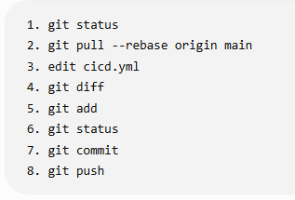

Check GitHub Actions
Go to:
GitHub → Github-Actions-Project → Actions
Run it again
The workflow should run successfully.
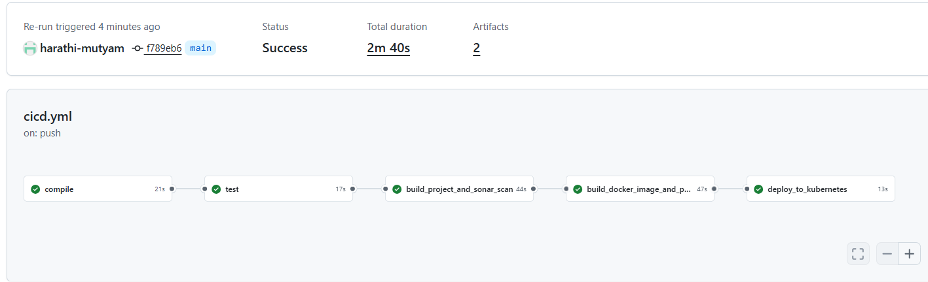

STEP 15.6 — Check Argo CD
Go back to Argo CD.
Open:
Applications → bankapprefresh SYNC synchronize
You should still see your application resources.
Because Argo CD is now responsible for deployment:
GitHub
↓
k8s/
↓
Argo CD
↓
EKS

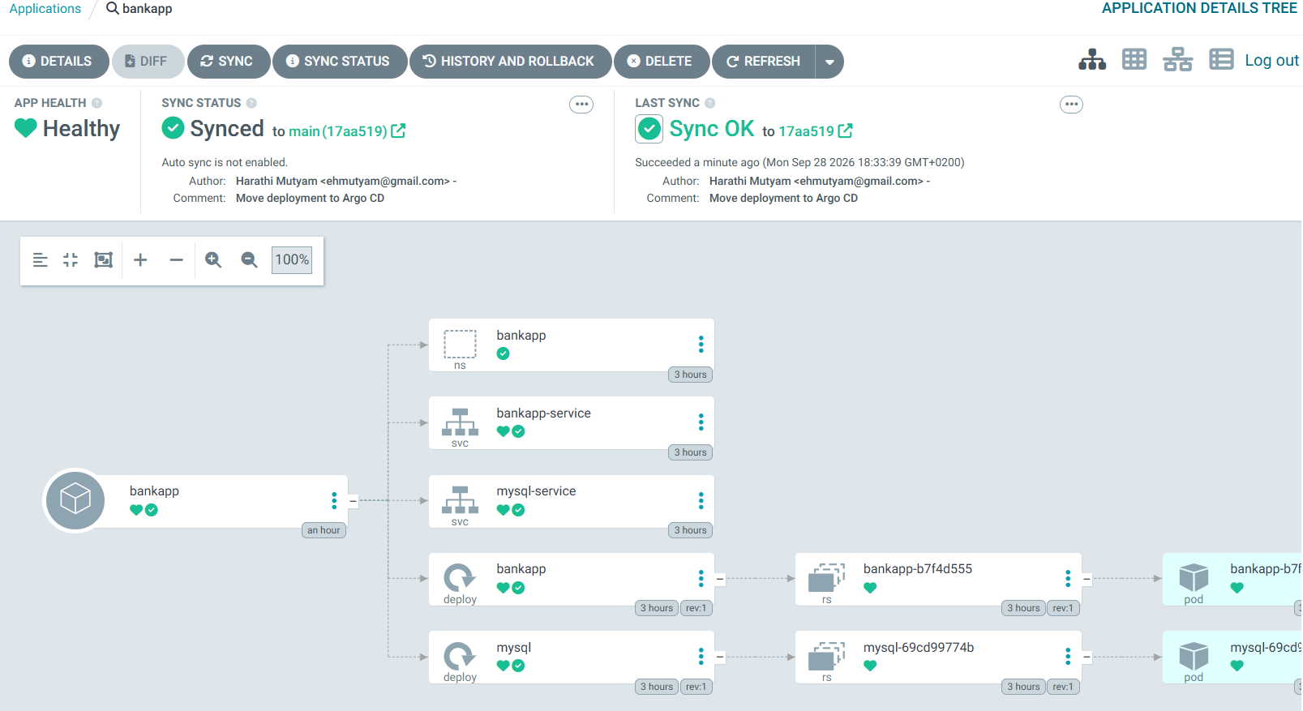

Argo CD GitOps setup is now working successfully.

STEP 16 — Verify GitOps from the Server EC2
Before we install Prometheus and Grafana, let's verify the Kubernetes side from your terminal.
Run: in server gitbash terminal

1. Check Argo CD Application
kubectl get applications -n argocd
Expected:
NAME SYNC STATUS HEALTH STATUS
bankapp Synced Healthy

Check Bankapp resources

kubectl get all -n bankapp
You should see your:
Pods
Services
Deployments
ReplicaSets
For example:
NAME READY STATUS RESTARTS
pod/bankapp-xxxxxxxx 1/1 Running 0
pod/mysql-xxxxxxxx 1/1 Running 0

3. Check the Argo CD-managed resources
Run:
kubectl get applications -n argocd -o wide
You should see:
bankapp Synced Healthy

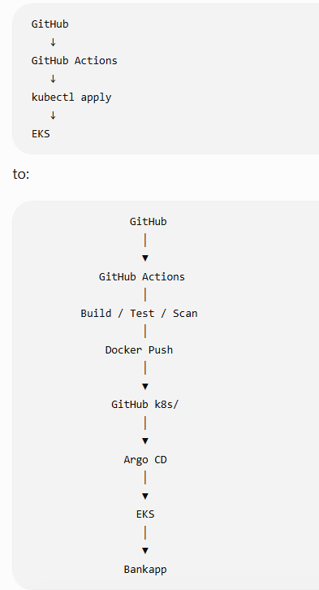

kubectl get svc -n bankapp

You should see your:
mysql-service
bankapp-service
For bankapp-service, you should have the AWS LoadBalancer address.
For example:
NAME TYPE EXTERNAL-IP
mysql-service ClusterIP ...
bankapp-service LoadBalancer xxx.elb.eu-north-1.amazonaws.com

copy the externalip(a0eae422614be4c7a9445cf6f58daf0d-985785709.eu-north-1.elb.amazonaws.com) of bankapp-service .paste the external ip in browser and test it.is it working or not

kubectl get applications -n argocd

kubectl get all -n bankapp

kubectl get svc -n bankapp

our Argo CD + EKS + Bankapp GitOps setup is fully working.

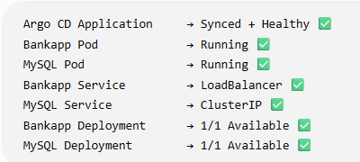
Now we will start Prometheus:

We will use Helm to install the Prometheus + Grafana monitoring stack.
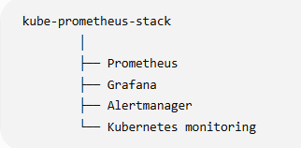
Check it in server ec2 gitbash terminal:
ubuntu@server:~/banking-app-cicd$ helm version

Install Helm
You are already on the correct Server EC2 gitbash terminal.

1. Download the Helm installation script
Run:
curl -fsSL -o get_helm.sh https://raw.githubusercontent.com/helm/helm/main/scripts/get-helm-3

2. Give the script execute permission

chmod 700 get_helm.sh

Run the installation script

./get_helm.sh

helm version

Add Prometheus Community repository
helm repo add prometheus-community https://prometheus-community.github.io/helm-charts
Expected:
"prometheus-community" has been added to your repositories

Update Helm repositories
helm repo update
Expected:
Update Complete. ⎈Happy Helming!⎈

create the monitoring namespace
kubectl create namespace monitoring

kubectl get namespace monitoring
NAME STATUS AGE
monitoring Active 10s

Install Prometheus + Grafana
We will install the kube-prometheus-stack.
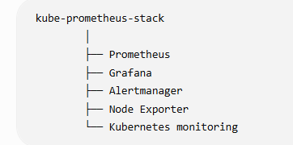

Install the stack
helm install monitoring \ prometheus-community/kube-prometheus-stack \ -n monitoring
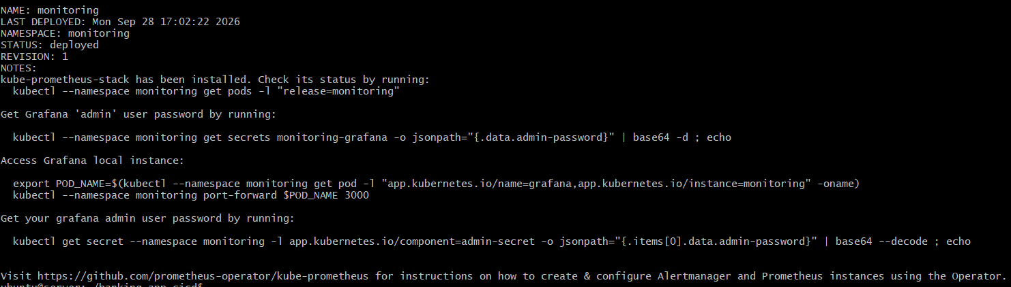
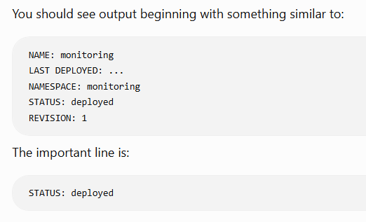

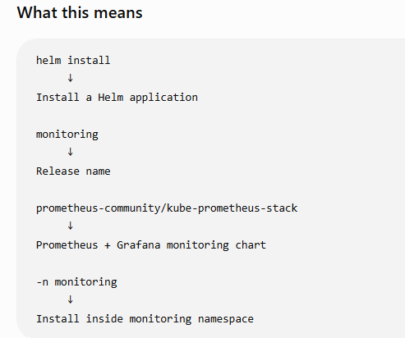
Check the Pods :
kubectl get pods -n monitoring
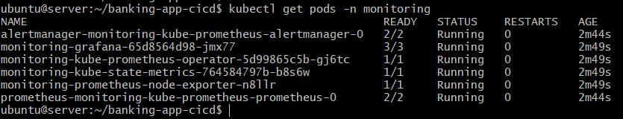

Now Prometheus + Grafana installed successfully.
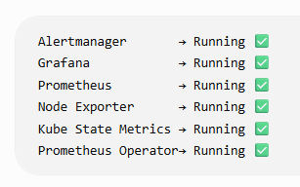
Now let's open Grafana.
Get the Grafana Password
kubectl --namespace monitoring get secret monitoring-grafana \
-o jsonpath="{.data.admin-password}" | base64 -d ; echo
Copy the password: edmzcEr3jrgPoe9uzWeG1V8HaijVtgbWNSuWU1OZ

Your Grafana login will be:
Username: admin
Password: <password you copied>

Open Grafana
Because Grafana is currently inside EKS, let's first check its Service.
kubectl get svc -n monitoring
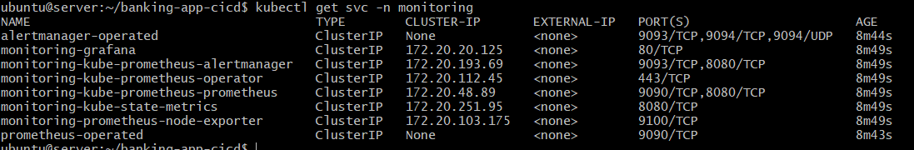
You should see something similar to:
NAME TYPE CLUSTER-IP EXTERNAL-IP
monitoring-grafana ClusterIP 172.20.x.x <none>
That's normal.
For now, we'll use port-forwarding instead of creating another AWS LoadBalancer.

Start Grafana Port Forward
kubectl port-forward svc/monitoring-grafana -n monitoring 3000:80
output will be like this
Forwarding from 127.0.0.1:3000 -> 3000

Forwarding from [::1]:3000 -> 3000

⚠️ Keep this terminal open.
The port-forward is active only while this command is running.

So Open one more server gitbash terminal

ssh -i Downloads/github-key.pem ubuntu@<public ip of server instance>
ubuntu@server:~$
cd ~/banking-app-cicd
Get Grafana password:
kubectl -n monitoring get secret monitoring-grafana -o jsonpath="{.data.admin-password}" | base64 -d ; echo

copy the password: edmzcEr3jrgPoe9uzWeG1V8HaijVtgbWNSuWU1OZ

Check Grafana service:
kubectl get svc -n monitoring
Your Grafana service is running correctly.
monitoring-grafana ClusterIP 172.20.20.125 <none> 80/TCP

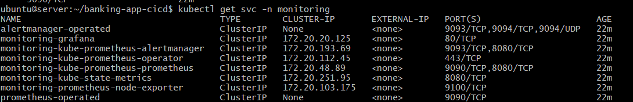
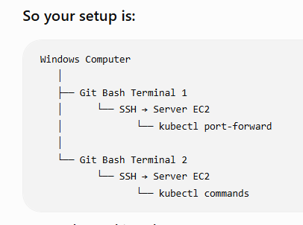

Step 1 — Check Terminal 1
Go back to your first Server EC2 terminal.
It should still be running:
kubectl port-forward svc/monitoring-grafana -n monitoring 3000:80
You should see:
Forwarding from 127.0.0.1:3000 -> 80

If you cant not see can you see like this

Forwarding from [::1]:3000 -> 3000 not a issue open another new server

instance gitbash terminal

Do not close Terminal 1. Do not type anything

Step 2 — Keep Terminal 2 open too
Your second terminal can remain at: run this below command
ubuntu@server:~/banking-app-cicd$

kubectl -n monitoring get secret monitoring-grafana -o jsonpath="{.data.admin-password}" | base64 -d ; echo

copy the grafana admin password
Terminal 1 → leave it running.
Terminal 2 → run the password command.
You don't need to run anything else there right now.

Current situation
Terminal 1
kubectl port-forward ...
↓
Server EC2 :3000
↓
Grafana
Now we need to connect your Windows browser to Server EC2.

Step 3 — Next we need the SSH tunnel
Now we need to connect:
Windows Browser
↓
Windows localhost:3000
↓
SSH tunnel
↓
Server EC2 localhost:3000
↓
kubectl port-forward
↓
EKS
↓
Grafana

Open another gitbash terminal 3 for server ec2 instance:
Write the below command like this

ssh -i Downloads/github-key.pem -L 3000:localhost:3000 ubuntu@13.50.101.82

ubuntu@server:~$

Step 4 — Open your Windows browser
Now open:
http://localhost:3000
You should see the Grafana login page.
Use:
Username
admin
Password
edmzcEr3jrgPoe9uzWeG1V8HaijVtgbWNSuWU1OZ

You will have 3 things open:
- Terminal 1 → kubectl port-forward — keep open
- Terminal 2 → SSH tunnel — keep open
- Browser → http://localhost:3000

In Grafana UI Dashboards (in the left menu) → Browse

If you see folders
Look for something like:
- Kubernetes
- Kubernetes / Compute Resources
- Node Exporter
- Prometheus
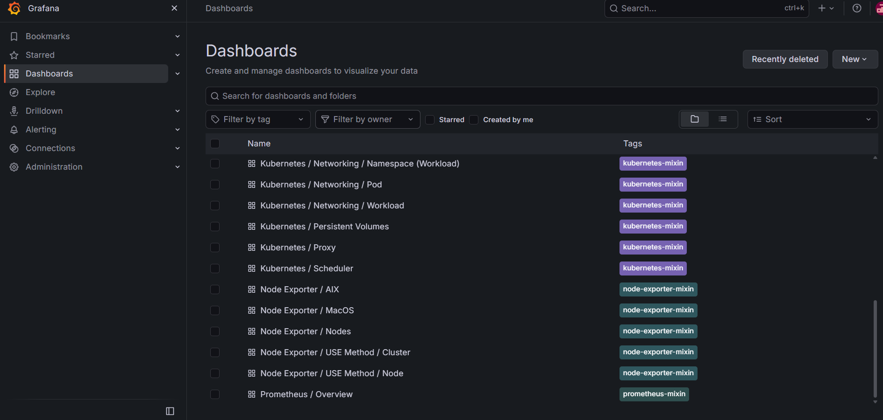
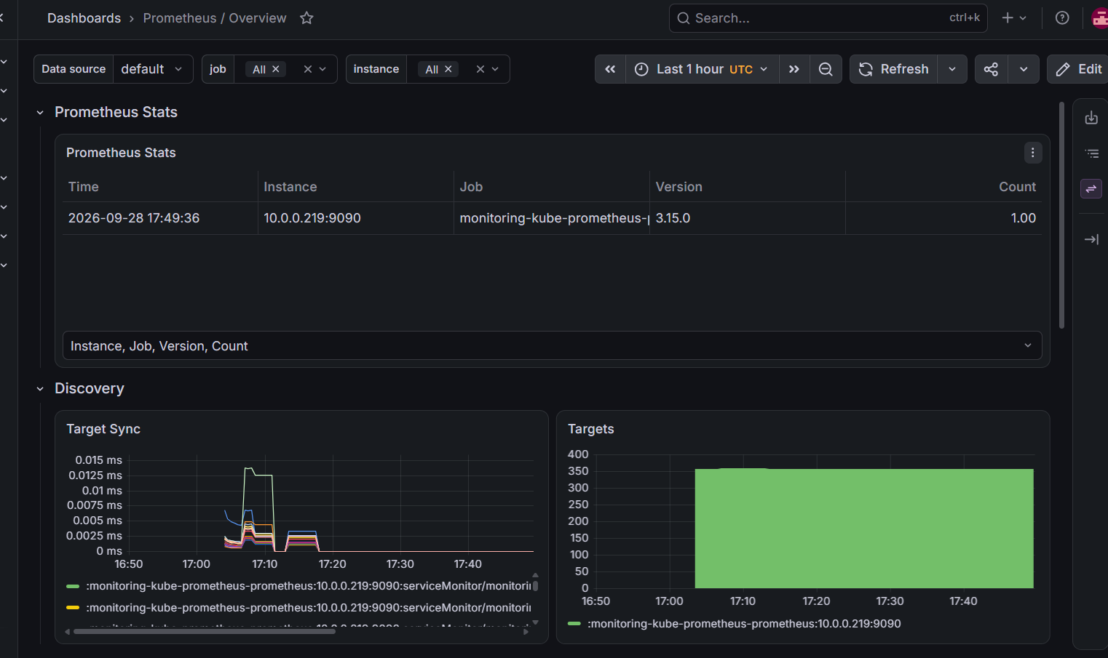
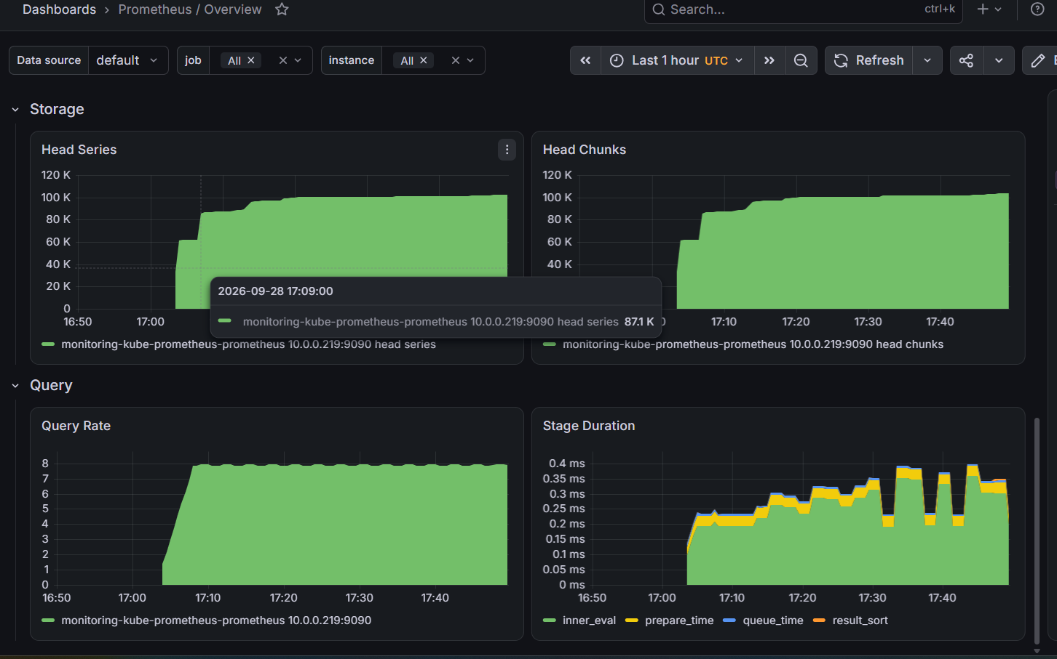

If you see them, don't create a new dashboard.

Click in Grafana browser Dashboards → Browse
Then click:
Kubernetes / Compute Resources / Cluster
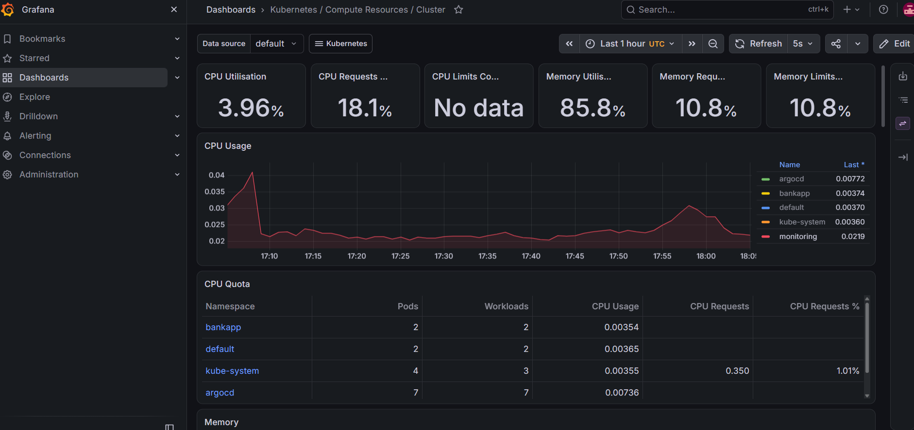

Grafana Dashboards → Browse and open:
Kubernetes / Compute Resources / Nodes Overview

Open server gitbash terminal 2 or terminal 3
Run these below commands
kubectl top pods -A --sort-by=memory
kubectl top nodes
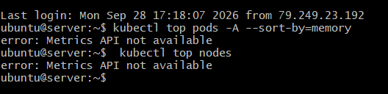

STEP 1 — Check whether Metrics Server exists
You are already in Server Terminal 2, so stay there.
Run:
kubectl get deployment metrics-server -n kube-system

Error from server (NotFound): deployments.apps "metrics-server" not found

Install Metrics Server
You are already in Server Terminal 2 git bash terminal:
ubuntu@server:~/banking-app-cicd$
Run this command:
kubectl apply -f https://github.com/kubernetes-sigs/metrics-server/releases/latest/download/components.yaml
You should see resources such as:
serviceaccount/metrics-server created
clusterrole.rbac.authorization.k8s.io/system:aggregated-metrics-reader created
deployment.apps/metrics-server created
service/metrics-server created

Check Metrics Server
kubectl get pods -n kube-system | grep metrics-server
output must be like this metrics-server-xxxxxxxxxx-xxxxx 1/1 Running 0 1m
kubectl top nodes
kubectl top pods -A --sort-by=memory

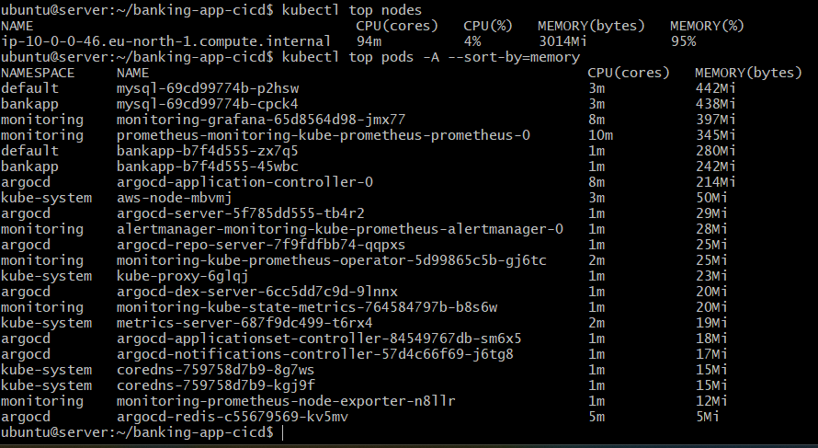

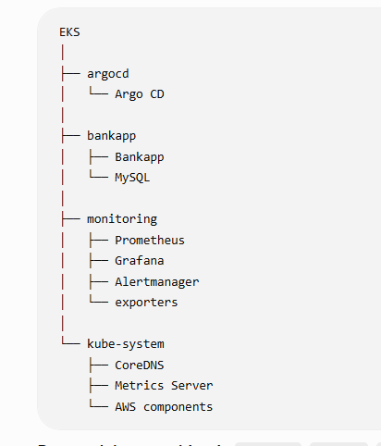

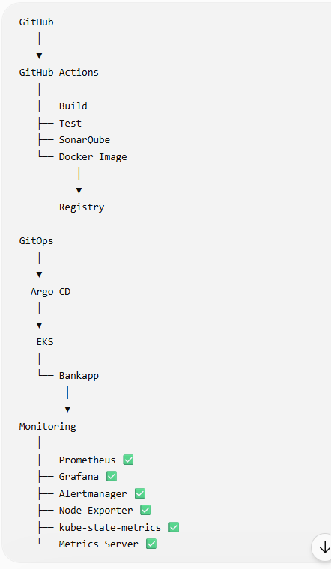

What you have completed
Component | Status
GitHub Actions CI/CD | ✅ Completed
SonarQube | ✅ Completed
Docker build/push | ✅ Completed
Kubernetes deployment | ✅ Completed
Argo CD / GitOps | ✅ Completed
Prometheus | ✅ Completed
Grafana | ✅ Completed
Alertmanager | ✅ Completed
Node Exporter | ✅ Completed
kube-state-metrics | ✅ Completed
Metrics Server | ✅ Completed
Grafana Kubernetes dashboards | ✅ Working
kubectl top nodes | ✅ Working
kubectl top pods | ✅ Working

Use Server gitbash Terminal 2.
Run:
kubectl delete deployment bankapp -n default
deployment.apps "bankapp" deleted
kubectl delete deployment mysql -n default
deployment.apps "mysql" deleted from default namespace
kubectl get deployments -A
You should still see:
bankapp bankapp
bankapp mysql

you cannot see default
kubectl get pods -A
Check memory

kubectl top nodes

kubectl top pods -A --sort-by=memory

Final memory result
Before cleanup:
Memory: 3014 MiB → 95%
After removing the duplicate default workloads:
Memory: 2340 MiB → 74%
CPU: 74m → 3%
So you recovered approximately 674 MiB of memory.

Your final Kubernetes state
You now have only the intended application:
bankapp namespace
├── bankapp pod ✅
└── mysql pod ✅
No duplicate default Bankapp/MySQL pods remain.

Monitoring is working
Your monitoring components are all running:
Prometheus ✅
Grafana ✅
Alertmanager ✅
Node Exporter ✅
kube-state-metrics ✅
Metrics Server ✅
And kubectl top is working:
CPU 3%
Memory 74%

🎉 Monitoring + Prometheus part: COMPLETE
You have now demonstrated:
EKS
│
┌──────────┴──────────┐
│ │
Bankapp Monitoring
│ │
MySQL Prometheus
│
┌───────────┼───────────┐
│ │ │
Grafana Alertmanager Exporters
│
Kubernetes
Dashboards
And your overall project is now:
GitHub
│
▼
GitHub Actions
│
├── Build
├── Test
├── SonarQube
└── Docker Image
│
▼
Registry
│
▼
Argo CD
│
▼
EKS
│
▼
Bankapp
│
▼
Prometheus + Grafana
You can consider the project implementation complete.

Check Alertmanager Pod
Use Server Git Bash Terminal 2.
ubuntu@server:~/banking-app-cicd$
Run:
kubectl get pods -n monitoring | grep alertmanager
You should see something similar to:
alertmanager-monitoring-kube-prometheus-alertmanager-0 2/2 Running

What this means
2/2 Running
means the Alertmanager Pod has both required containers running.
Check Alertmanager Service
kubectl get svc -n monitoring | grep alertmanager
monitoring-kube-prometheus-alertmanager ClusterIP ... 9093/TCP
Access Alertmanager
kubectl port-forward svc/monitoring-kube-prometheus-alertmanager -n monitoring 9093:9093
You should see:
Forwarding from 127.0.0.1:9093 -> 9093
Forwarding from [::1]:9093 -> 9093

Important
Keep this terminal open.

Open another server gitbash terminal

Create SSH Tunnel
Open a new Windows Git Bash terminal.
Run:
ssh -i Downloads/github-key.pem -L 9093:localhost:9093 ubuntu@<public ip of server instance 13.50.101.82>

Keep this terminal open too.
Now open your Windows browser:
http://localhost:9093
You should see the Alertmanager web interface.
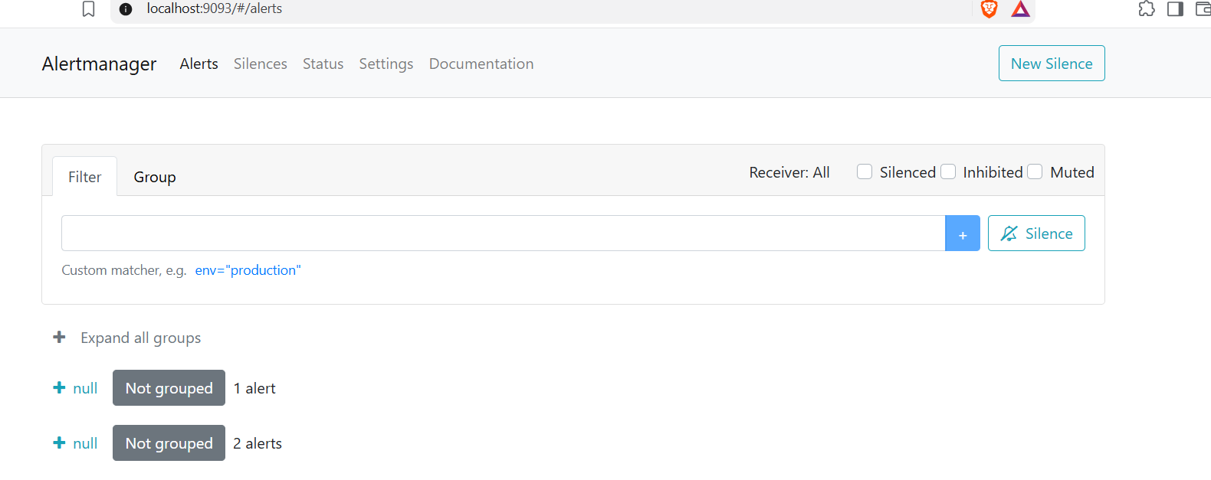

STEP 5 — Understand the Alertmanager Page
You should see sections related to:
Alerts
Silences
Status

Alerts
Shows alerts received by Alertmanager.

Silences
Allows you to temporarily silence an alert.
Example:
CPU alert
↓
Alertmanager
↓
Silence for 1 hour

Status
Shows Alertmanager configuration and status.

STEP 6 — Check Prometheus Alerts
Now we need to see whether Prometheus already has alert rules.
Open another Server Git Bash terminal.
Run:
kubectl get prometheusrules -n monitoring
You should see several PrometheusRule resources.
You can also check:
kubectl get prometheusrules -n monitoring -o name
The kube-prometheus-stack normally installs many predefined Kubernetes alerts.

STEP 7 — Check Alerts from Prometheus
First find the Prometheus service:
kubectl get svc -n monitoring | grep prometheus
You should see:
monitoring-kube-prometheus-prometheus
Port-forward it:
kubectl port-forward svc/monitoring-kube-prometheus-prometheus -n monitoring 9090:9090
Then open another Windows server Git Bash terminal:
ssh -i downloads/github-key.pem -L 9090:localhost:9090 ubuntu@<public ip of server ec2 instance13.50.101.82>
Open:
http://localhost:9090
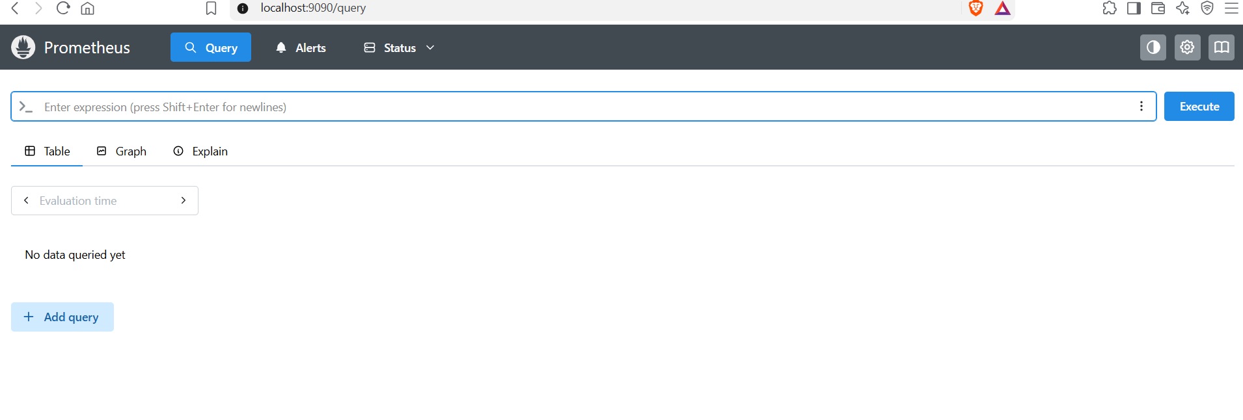
Then select:
Alerts
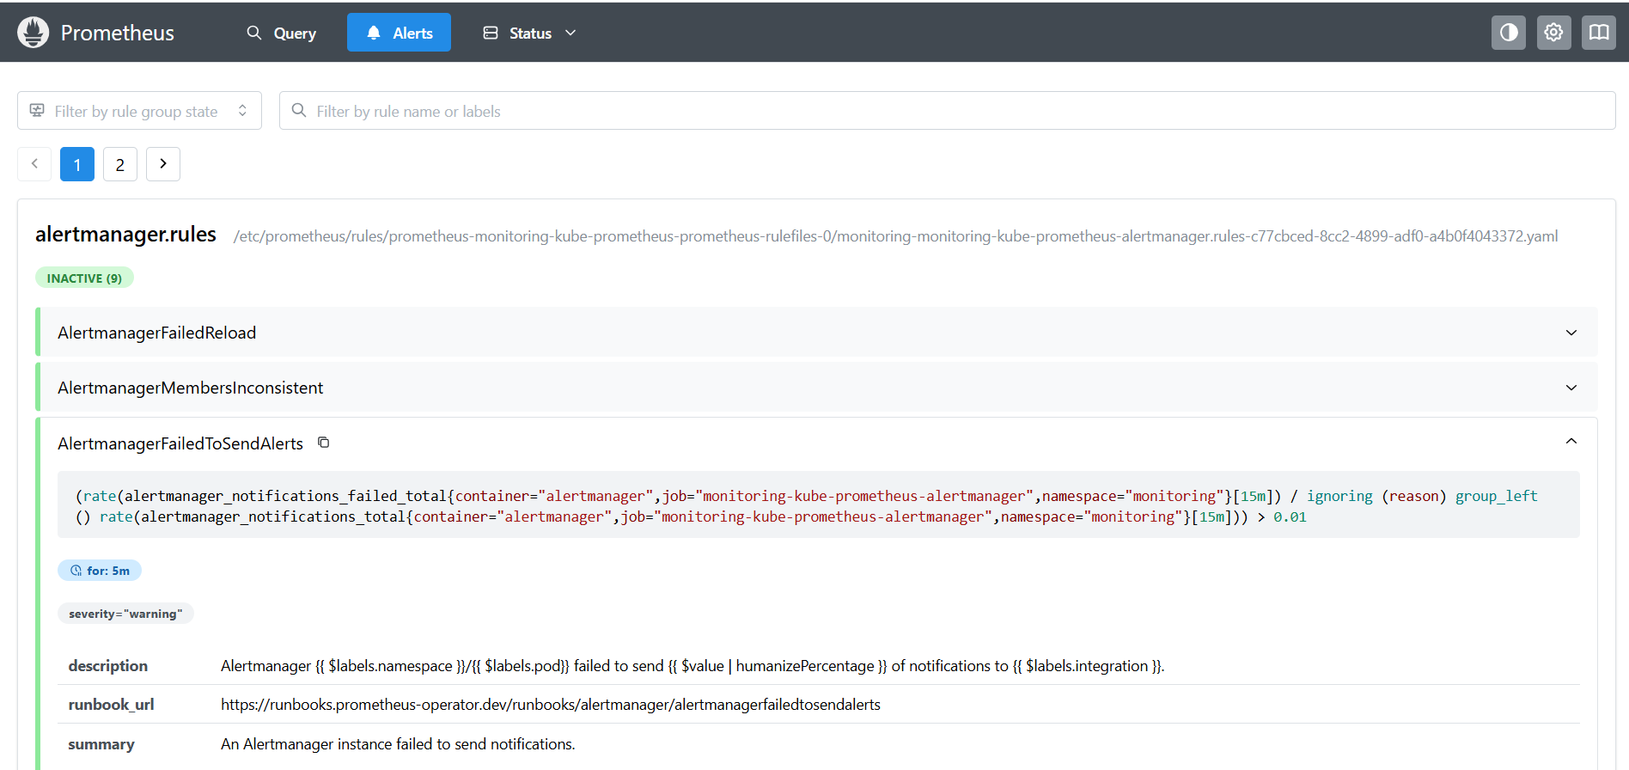
You should see the Prometheus alert rules.

STEP 8 — Understand the Complete Alert Flow
This is important for your presentation.
Kubernetes
│
▼
Prometheus
│
Alert Rule triggered
│
▼
Alertmanager
│
┌──────────┴──────────┐
│ │
Grouping Routing
│ │
▼ ▼
Alerts Notification
│
Email / Slack
For example:
Node memory becomes very high
↓
Prometheus detects condition
↓
Prometheus sends alert
↓
Alertmanager receives alert
↓
Alertmanager processes it
↓
Notification is sent

STEP 9 — Email Notification
If you want your project to demonstrate real notifications, we can configure email.
For example:
Prometheus
↓
Alertmanager
↓
SMTP
↓
Your Email
For Gmail, this normally requires an App Password, not your normal Gmail password.
For your project documentation, the configuration concept is:
receivers:
- name: email-alert
email_configs:
- to: your-email@example.com
However, don't add this configuration yet.
First let's verify that your existing Alertmanager installation and alert rules are working.

STEP 10 — Important: Don't Reinstall Alertmanager
You already have:
monitoring
└── alertmanager-monitoring-kube-prometheus-alertmanager-0
└── 2/2 Running
So you do not need:
helm install alertmanager ...
Alertmanager was already installed automatically by:
helm install monitoring \
prometheus-community/kube-prometheus-stack \
-n monitoring

Your Alertmanager Project Architecture
Your final monitoring architecture can be documented as:
EKS
│
┌───────────┴───────────┐
│ │
Bankapp Monitoring
│ │
MySQL Prometheus
│
┌──────────────┼──────────────┐
│ │ │
Node Exporter kube-state-metrics Rules
│
▼
Alertmanager
│
┌────────┴────────┐
│ │
Email Slack

Start only with STEP 1 now
In Server Git Bash Terminal 2, run:
kubectl get pods -n monitoring | grep alertmanager

or your complete banking-app-cicd project, I recommend deleting resources in a controlled order so you don't leave AWS/EKS resources running and generating charges.
Because your project contains EKS, EC2, Argo CD, Prometheus, Grafana, Alertmanager, Metrics Server, and GitHub Actions, use the procedure below.

Complete Project Deletion Procedure

Step 1 — Stop port-forward sessions
On Server Terminal 1, if Grafana port-forward is running:
Ctrl + C
If Alertmanager port-forward is running in another terminal:
Ctrl + C
On your Windows Git Bash SSH tunnel, also press:
Ctrl + C

Step 2 — Check the EKS resources
On Server EC2:
kubectl get nodes
Expected:
NAME STATUS ROLES AGE
ip-10-0-0-46.eu-north-1.compute.internal Ready <none> ...
Then:
kubectl get pods -A
This is only a final verification before deletion.

Step 3 — Delete Argo CD Application
First check:
kubectl get applications -n argocd
You should see:
bankapp Synced Healthy
Delete the Argo CD Application:
kubectl delete application bankapp -n argocd
Verify:
kubectl get applications -n argocd
Expected:
No resources found in argocd namespace.

Step 4 — Delete the Monitoring Stack
Your monitoring stack was installed using Helm with release name:
monitoring
Check:
helm list -n monitoring
You should see something similar to:
monitoring
Delete it:
helm uninstall monitoring -n monitoring
Expected:
release "monitoring" uninstalled
This removes the main:
- Prometheus
- Grafana
- Alertmanager
- Node Exporter
- kube-state-metrics
- Prometheus Operator
resources installed by that Helm release.

Step 5 — Delete Metrics Server
Check:
kubectl get deployment metrics-server -n kube-system
Then delete it:
kubectl delete -f https://github.com/kubernetes-sigs/metrics-server/releases/latest/download/components.yaml
Verify:
kubectl get pods -n kube-system | grep metrics-server
There should be no Metrics Server pod.

Step 6 — Delete the Bankapp Namespace
Because Argo CD has already been removed, you can delete the application namespace.
kubectl delete namespace bankapp
Wait for it to finish.
Then check:
kubectl get namespace bankapp
Expected:
Error from server (NotFound): namespaces "bankapp" not found
This removes the Bankapp resources inside that namespace, such as:
- Bankapp Deployment
- Bankapp Service
- MySQL Deployment
- MySQL Service
- ConfigMaps/Secrets associated with the namespace
- Pods

Step 7 — Delete Argo CD
Now remove the Argo CD namespace:
kubectl delete namespace argocd
Verify:
kubectl get namespace argocd
Expected:
Error from server (NotFound): namespaces "argocd" not found

Step 8 — Delete Monitoring Namespace
After Helm uninstall:
kubectl get pods -n monitoring
If the namespace is empty or only contains leftover resources, delete it:
kubectl delete namespace monitoring
Verify:
kubectl get namespace monitoring
Expected:
Error from server (NotFound): namespaces "monitoring" not found

Step 9 — Final Kubernetes Check
Run:
kubectl get pods -A
You should now see mainly Kubernetes/EKS system components under:
kube-system
For example:
coredns
kube-proxy
aws-node
The following should be gone:
bankapp
monitoring
argocd
grafana
prometheus
alertmanager
metrics-server

Step 10 — Delete the EKS Cluster
⚠️ This is the major deletion step.
Before deleting, check:
aws eks list-clusters --region eu-north-1
You should see:
{
"clusters": [
"eks-cluster"
]
}
Delete the cluster:
aws eks delete-cluster --name eks-cluster --region eu-north-1
Expected:
{
"cluster": {
"name": "eks-cluster",
...
}
}
Check the status:
aws eks describe-cluster --name eks-cluster --region eu-north-1 --query "cluster.status"
It may show:
"DELETING"
Wait until the cluster is completely deleted.
Then:
aws eks list-clusters --region eu-north-1
Expected:
{
"clusters": []
}

Terraform destroy –auto-approve

Step 11 — Check AWS EC2 Instances
Your project has three EC2 instances:
- Runner EC2
- SonarQube EC2
- Server EC2
Check them in AWS Console:
AWS Console → EC2 → Instances
Identify the three project instances.
Then terminate them if you want to completely remove the project infrastructure.
Select the instance → Instance state → Terminate instance.
⚠️ Make sure you are terminating the project instances, not another EC2 instance you want to keep.

Step 12 — Delete EKS-Related AWS Resources
After EKS deletion, check:

Load balancers
AWS Console:
EC2 → Load Balancers
Delete any load balancer created specifically for this project.

Security Groups
Check:
EC2 → Security Groups
Delete unused project security groups.
Do not delete a security group if another AWS resource still uses it.

EBS Volumes
Go to:
EC2 → Volumes
Look for unused volumes created by the project.
Only delete volumes that you have confirmed are no longer needed.

Step 13 — Delete the VPC
If this VPC was created specifically for this project, check:
AWS Console → VPC → Your VPCs
Find the project VPC.
Before deleting it, make sure the EKS cluster, EC2 instances, load balancers, NAT Gateway, and other dependent resources are already removed.
Then:
VPC → Your VPCs → Select VPC → Actions → Delete VPC

Step 14 — Check NAT Gateway
This is especially important because NAT Gateway can continue generating charges.
Go to:
AWS Console → VPC → NAT Gateways
If the NAT Gateway belongs to this project:
- Select it.
- Delete NAT Gateway.
- Wait until it is deleted.
Then check:
Elastic IPs
Release any Elastic IP associated only with this project and no longer needed.

Step 15 — Remove GitHub Actions Runner
On the Runner EC2, if you registered a self-hosted runner:
Go to:
GitHub → banking-app-cicd → Settings → Actions → Runners
Find your self-hosted runner.
Remove it from GitHub.
Then you can terminate the Runner EC2.

Step 16 — SonarQube EC2
If you no longer need SonarQube for this project:
- Stop/terminate the SonarQube EC2.
- Remove its associated resources if they are project-specific.
- Check EBS volumes.
- Check Elastic IPs.

Step 17 — Server EC2
After EKS and all Kubernetes work is finished, terminate the Server EC2 if it was created only for this project.
This is the EC2 where you used:
kubectl
helm
aws

Step 18 — GitHub Repository
Your repository is:
banking-app-cicd
If you want to keep the project as documentation/portfolio material, do not delete the repository.
You can keep:
.github/
k8s/
pom.xml
Dockerfile
README.md
Even after AWS infrastructure is deleted, the GitHub repository can remain as your project source code and documentation.

Final AWS Cost Check
After everything is deleted, check these areas:
Resource | Check
EKS cluster | Deleted
EC2 Runner | Terminated
EC2 SonarQube | Terminated
EC2 Server | Terminated
NAT Gateway | Deleted
Elastic IPs | Unused ones released
Load Balancers | Deleted
EBS Volumes | Unused ones deleted
VPC | Deleted if project-specific
Security Groups | Unused ones removed
GitHub Runner | Deregistered
GitHub Repository | Keep if you want

Important
Do not execute all commands blindly at once. Since this deletes real AWS infrastructure, I recommend doing it one step at a time.
Start with Step 1:
kubectl get applications -n argocd

